1. Lion Gate:

Seen at the start of the tour, at the entrance to the site.

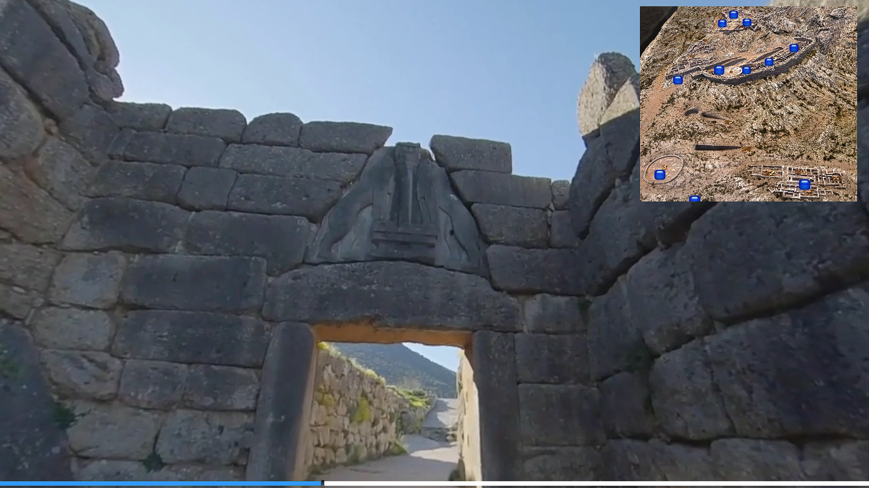

2. Grave Circle A:

After passing the Lion Gate, Grave Circle A is seen in a lower elevation to the right.

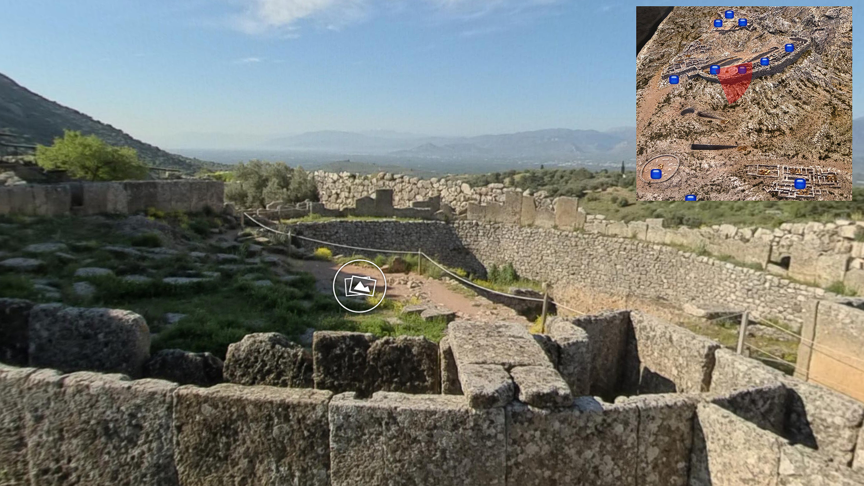

3. Ceiling of the tholos-style tomb:

The tomb itself is not past the Lion Gate, but away from the main ruins to the south-southwest.

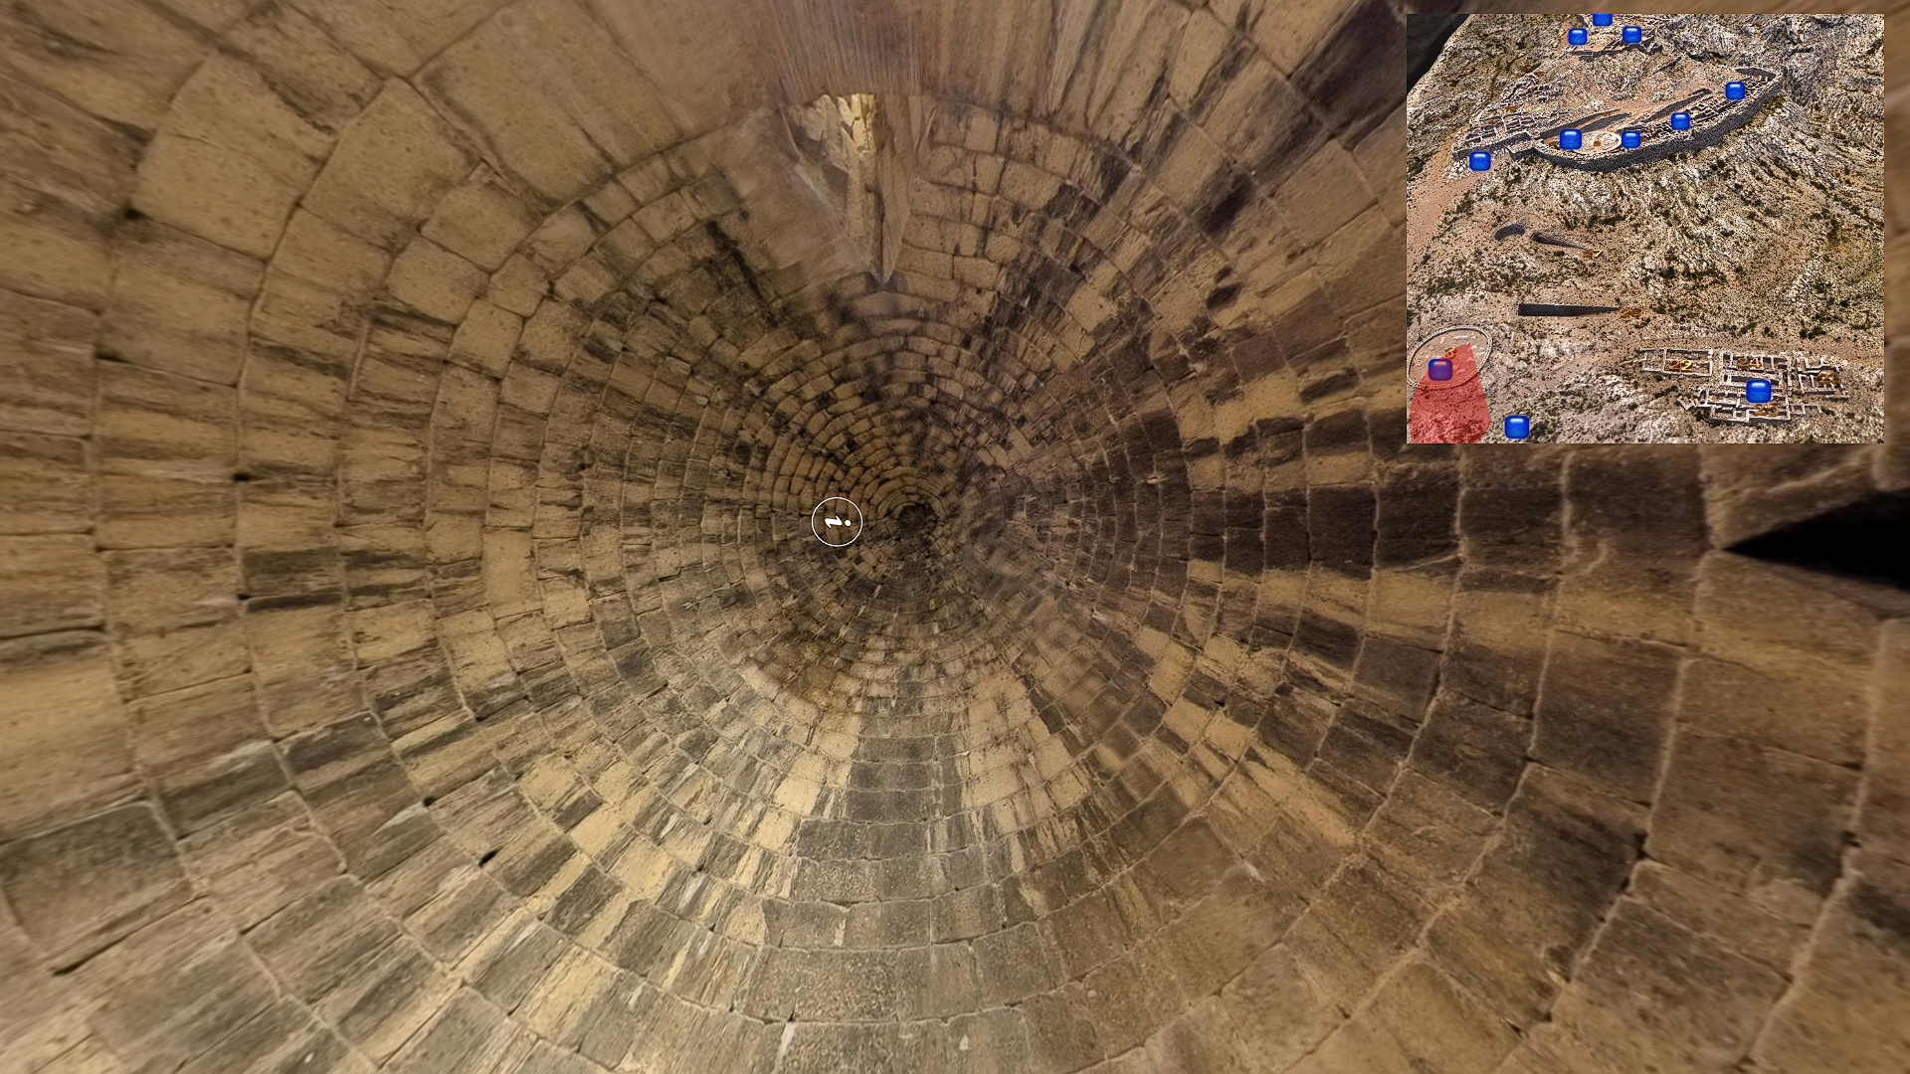

4. Painted Reconstruction of the megaron palace from the citadel:

Seen by the North Gate, to the east.

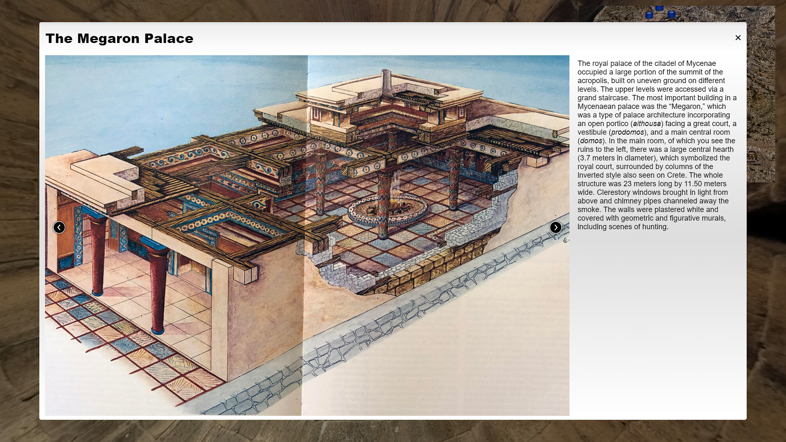

5. One of the golden death masks from Grave Circle A:

Found in Grave Circle A.

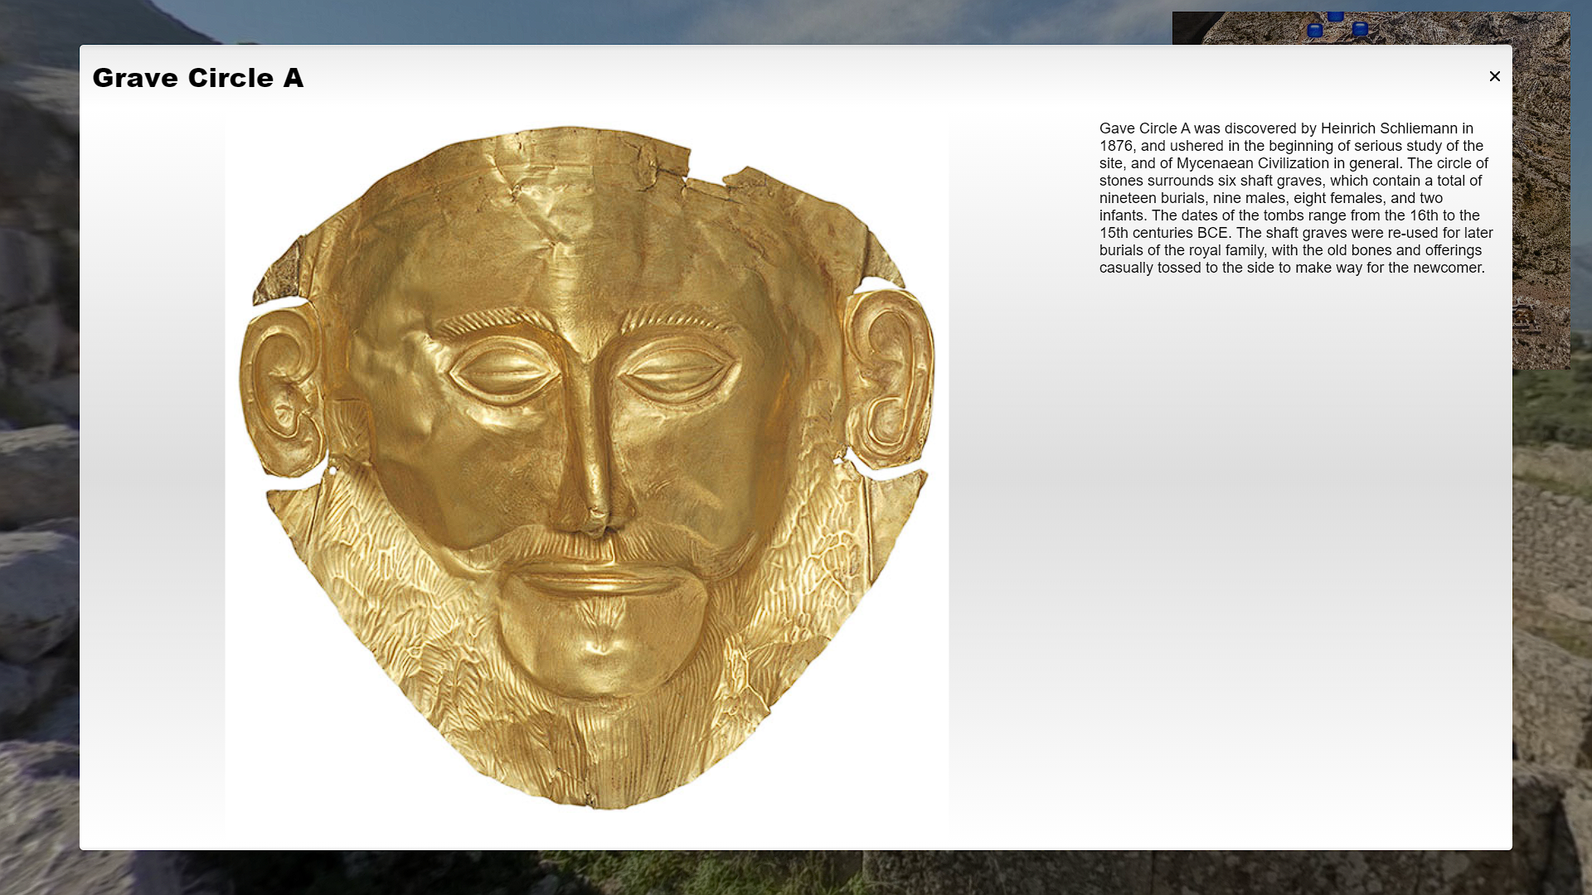

The most convincing evidence that this is the home to a state-level society is The Treasury of Atreus, as it is magnificent and large and housed beautiful carvings and ornaments. Additionally, the valuable belongings found in Grave Circle A and Grave Circle B provide hints of the importance of the individuals buried in each grave circle. Each grave had a slew of precious metals and stones, such as gold and crystal rock.